**Academic Services Group**

Nathan Cooley, Brad Ewing, Christopher Hebert, Kaleigh Key, Shelby Pace, Michael Towns

Flora and Fauna

Final Requirements Document

Table of Contents

**Preface1**

**Introduction2**

Need for Application2

Application Description2

Application Clients3

Project Team Members3

**Glossary4**

**User Requirements Definition6**

Functional Requirements6

Nonfunctional Requirements8

**System Architecture9**

**System Requirements Specification10**

System Requirements Corresponding to Functional Requirements10

System Requirements Corresponding to Nonfunctional Requirements 14

**System Models15**

Context Diagram15

Data Flow Diagram16

Use Case Diagrams17

**Prototype Information23**

Initial Prototype23

Second Prototype24

Prototype Objectives27

Prototype Feedback28

Requirements Affected28

**System Evolution29**

Fundamental Assumptions29

Anticipated Changes29

**Client Signatures30**

**Preface**

This is the requirements document for the Flora and Fauna application. This document will present the user and system requirements for the application along with the system models and evolution. The expected readers of the document are our two clients Dr. Box and Todd Buffington as well as Dr. Cherry who will evaluate this document.

|  |  |  |  |
| --- | --- | --- | --- |
| **Version** | **Revision Date** | **Rationale** | **Version Changes Summary** |
| 1.0 | December 18, 2017 | Created fundamental requirements to receive feedback from client. | Initial Version  - 10 functional requirements  - 2 nonfunctional requirements |
| 2.0 | January 3, 2018 | Added additional requirements to meet clients’ needs. Created two prototypes to receive client feedback on UI and functionality. | Version 1 update  - Added 21 functional requirements  - Added 1 nonfunctional requirement  - requirements grouped logically  - 2 prototypes |
| 3.0 | January 24, 2018 | Created models of the application to show to clients and to establish system boundaries. | Version 2 update  - Created system architectural model  - Created context diagram  - Created use case diagram  - Created data flow diagram  - Created system requirements  - Altered and added new functional requirements  - Added additional sections to document such as introduction, glossary, etc. |

**Introduction**

**Need for Application**

The Flora and Fauna application will allow wildlife experts, nature enthusiasts, and general users to search for species within their location. For example, if the user sees a bird that they are not familiar with, they can use the application to search for birds in their location. The application will then provide relevant species that match the user’s search. The user can then view a page containing additional information about the species. A map displaying the recorded observations of a species will also be provided through the application by the BISON Web Map Service.

The application will provide an intuitive interface allowing users to search for species information and observations using a singular application.

**Application Description**

The application will allow the user to search for species using a search bar. The user can type in the common name, scientific name, state, or county/parish/organized borough to view relevant results. The application will perform queries to the EOL, GBIF, and BISON APIs, using the user’s search terms to find species that match. Each species that matches the user’s search will be displayed in a selectable, scrollable list. Each of the results will have an image of the species with its common name followed by its scientific name. The user will be given the option to view additional information about each species upon selection of the result. The species page for the result will contain a description of the species provided by the MediaWiki API.

When the user performs a search, the user can filter results by location, taxonomic information, habitat, and event date to narrow down the search so that they can find the organisms that they are looking for quickly. Each time the user applies a filter it will run a new query to the APIs with the additional filter.

The application will also allow the user to see recorded observations of a selected species. The BISON API records observations of species, so this API will be queried if the user wants to view the observations of a selected species. The user can filter observations by state, county, and their GPS location. The application will also include a “What’s Around Me” button that will display the observations of all species within a certain radius of the user’s GPS location.

To assist the user in keeping track of his or her past observations, the application will allow the user to save records within the application. These records can be image or audio recordings or a combination of the two, which can be enhanced with the attachment of location information.

A far reaching goal is to add image recognition to the application. The user would be able to upload an image to the application, and the application would use Google’s Vision API to identify the species in the image.

**Application Clients**

The Flora and Fauna application is a general product that can be used by any nature enthusiasts; however, we have selected two clients to assist with requirements elicitation.

One of our clients is Dr. Box who is a nature photographer. Dr. Box wants the application to display observations of species so that he knows where to travel to photograph these species. He also wanted the ability to record his own observations to the application to notify other users of the application.

Our next client is Todd Buffington who works for the Louisiana Department of Wildlife and Fisheries. Todd wanted the ability to search for species in his location and filter them by habitat.

Our newest client is Emma Boehm, an Ecology student from Minnesota. Emma had a forestry internship where she learned to identify different trees, and an app like ours would have been useful for her in geographic areas where she was not familiar.

We have included user and system requirements which will satisfy the needs of our clients so that they may benefit from the final product.

**Project Team Members**

Nathan Cooley

Brad Ewing

Christopher Hebert

Kaleigh Key

Shelby Pace

Michael Towns

**Glossary**

**Amazon Web Service (AWS)**

Platform for hosting websites and services online provided by Amazon.

**Application Programming Interface (API)**

A set of clearly defined methods to communicate with a piece of software. Allows for simpler access to the databases.

**Architectural model**

A model of the software showing the various layers and the components of each layer.

**Biodiversity Information Serving Our Nation (BISON)**

Database and mapping resource of species occurrence data in the United States.

**BISON Web Map Service (BISON WMS)**

Service which can be used to compose data from BISON in a mapping application (Google Maps)

**Cache**

Local storage of data for faster access.

**Context Diagram**

Model showing the interaction between the software and external entities.

**Data Flow Diagram**

Model showing the data being transferred between two or more entities.

**Encyclopedia of Life (EOL)**

Database of species across the globe containing descriptions, images, common names, and other data.

**Functional Requirements (FR)**

Requirements for what the application should do and functionality it should have.

**Geographic Information System (GIS)**

Data related to biome and habitats based on geographic location.

**Global Biodiversity Information Facility (GBIF)**

Database of species occurrence data across the globe containing mapping services, names, identifiers, and descriptions.

**Global Positioning System (GPS)**

System for locating a specific position on the globe.

**Google’s Vision API**

API for analyzing the content of an image using machine learning.

**Google Maps**

Web mapping service developed by Google

**Image Recognition (IR)**

Programmatically analyzing and identifying what is contained by an image.

**Local Database**

Database of offline data and media recorded by the user.

**Nonfunctional Requirements (NFR)**

Requirement on how well the system as a whole operates and what platforms it runs on.

**Prototype**

Initial version of the project for testing and feedback.

**Query**

Request sent to a database for information.

**System Requirements**

Requirements defining the limits of the system, including data types and lengths.

**Taxonomy**

Science of naming groups of biological organisms.

**Use Case Diagram**

Diagram showing how different entities interact with different systems of the software.

**User Interface (UI)**

The components of the software that the user interacts with to manipulate the application.

**MediaWiki API**

API for accessing the information hosted by Wikipedia.

**User Requirements Definition**

**Functional Requirements**

***Basic Search***

|  |  |
| --- | --- |
| **FR1:** | The user shall be able to search by scientific or common name. |
| **FR2:** | A user search shall produce a selectable list of species names, with the common name preceding the scientific name. |
| **FR3:** | The selectable list should display a preview image of the species next to its name. |
| **FR4:** | The application will have a “What’s Around Me?” button on the home screen which will populate a list of the species within a mile radius specified by the user (defaulting to 10 miles). |
| **FR5:** | The application shall keep a record of past searches made by the user. |
| **FR6:** | The user shall be able to specify the type of search he or she is making (common name, scientific name, state, or state with county/parish/organized borough). |

***Filter***

|  |  |
| --- | --- |
| **FR7:** | The application shall filter search results using the user’s GPS, showing the species within a range specified by the user (defaulting to 50 miles). |
| **FR8:** | The application shall populate a list of the species within a state which is selected or searched for by the user. |
| **FR9:** | The application shall allow the user to obtain a list of the species within a selected or searched for county, parish, or organized borough. |
| **FR10:** | A user shall be able to filter search results by selecting a taxonomic rank. This includes kingdom, phylum, class, order, family, genus, and species. |
| **FR11:** | The user shall be able to filter his or her search for species by inputting a specific event date. |
| **FR12:** | The user shall be able to select multiple filters to widen or narrow his or her search. |

***Species Page***

|  |  |
| --- | --- |
| **FR13:** | When selecting the preview image or the species name, the user shall be directed to a page containing additional information about the species. |
| **FR14:** | The species page should have a link to a page (EOL or MediaWiki) which will provide more information about the species. |
| **FR15:** | The species page shall include a citation which gives credit to the data provider. |

***Personal Recordings***

|  |  |
| --- | --- |
| **FR16:** | The user shall have the ability to access his or her camera within the app to take and upload photos of observed organisms. |
| **FR17:** | The user shall be able to take and upload audio recordings of observed organisms. |
| **FR18:** | The user shall be able to group saved images and audio recordings under a specific name. |
| **FR19:** | The application shall allow the user to add a location to their photo and/or audio recording. The user can select a specific location or use their current GPS location. |
| **FR20:** | The personal recordings page shall have a list of the user’s recordings along with icons for using the mobile device’s camera or microphone. |

***Downloading***

|  |  |
| --- | --- |
| **FR21:** | The application should offer a way to download data from a set location for offline use. |

***Settings***

|  |  |
| --- | --- |
| **FR22:** | The user shall be able to access the settings menu through a button in the top right hand corner of the screen. |
| **FR23:** | The settings menu shall contain a toggle to enable/disable preview images, showing only the species names. |
| **FR24:** | The settings shall allow the user to clear his or her search history. |
| **FR25:** | The settings shall allow the user to clear the cache of downloaded data. |
| **FR26:** | The user shall be able to change the distance that the “What’s Around Me?” button searches within the settings. |

***Map***

|  |  |
| --- | --- |
| **FR27:** | The user should be able to do a map search for a species which shows the locations where the species was observed. |
| **FR28:** | The user should be able to click the observation on the map and be directed to a page with additional information about the species/observation. |

***Basic Features***

|  |  |
| --- | --- |
| **FR29:** | The application shall have a banner that directs the user back to the home screen. |
| **FR30:** | The application shall have a help page providing a short tutorial detailing the functions of the application which will be accessible through a button in the top left hand corner of the screen. |
| **FR31:** | The application shall utilize multiple APIs to acquire information about species, such as name, location, data provider, etc. |
| **FR32:** | The application shall have a back button on each page, allowing the user to return to the previous page. |

***Image Recognition***

|  |  |
| --- | --- |
| **FR33:** | The application should be able to perform image recognition when the user inputs an image of a species. |

**Nonfunctional Requirements**

|  |  |
| --- | --- |
| **NFR1:** | An untrained user should be able to intuitively navigate the simple search method to find information about a species. |
| **NFR2:** | This application shall translate on all screen sizes so that a user with any type of Android phone can view the application properly. |
| **NFR3:** | The application shall be able to function without significant loading times using only a limited cell connection (3G, minimum). |

**System Architecture**

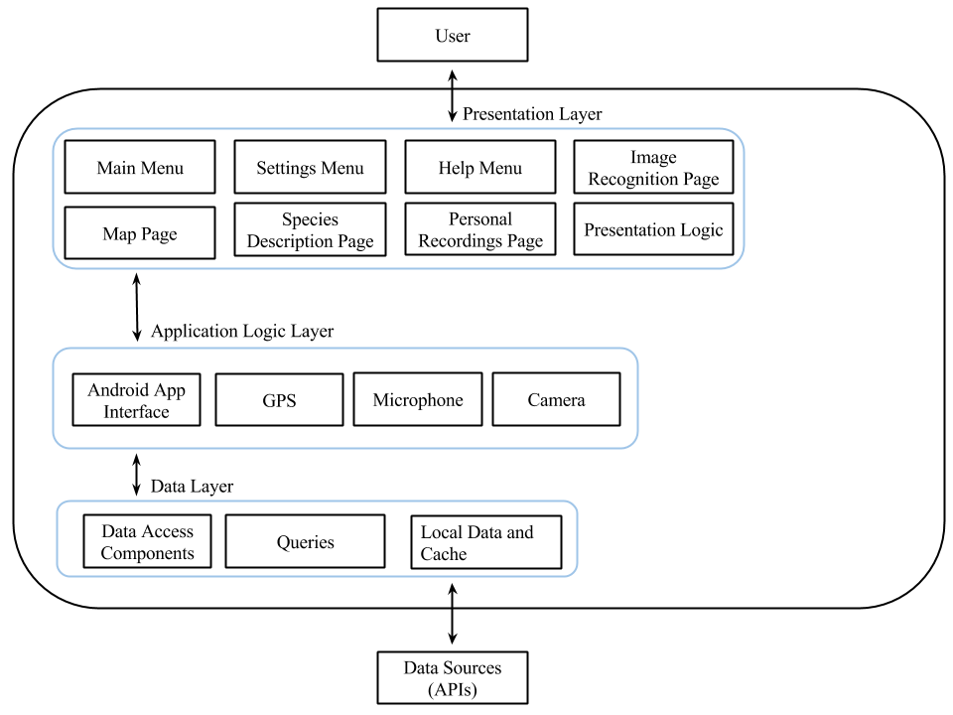

**Presentation Layer**

The presentation layer shows an overview of the various UI components with which the user will interact. The logic associated with these components is also in this layer.

**Application Logic Layer**

The application logic layer displays the applications interface along with components within the mobile device which will be utilized.

**Data Layer**

The data layer contains the components for accessing the data, the queries, and the storage location for local data. Data is accessed from the exterior data sources (APIs).

**System Requirements Specification**

**System Requirements Corresponding to Functional Requirements**

***Basic Search***

|  |  |
| --- | --- |
| **SFR1:** | The user shall be able to search for organisms by typing the common name or the scientific name into a search bar. The search bar will have a 255 character limit. |
| **SFR2:** | A user’s search will generate a maximum of 10 results at a time. The user can click a view more results option to view 10 more results. |
| **SFR3:** | Each image in the selectable list will be 400px by 400px. The image will appear to the left of each species result. |
| **SFR4.1:** | The application shall ask the user for access to his or her location upon initial use of the “What’s Around Me?” button. |
| **SFR4.2:** | The user’s GPS location will be used as the center point of the area searched. |
| **SFR4.3:** | This feature will not work unless the user allows the application to use their GPS location. |
| **SFR5:** | The application shall keep a record of a total of 20 past searches before automatically clearing the least recent search. |
| **SFR6:** | The search bar shall produce radio buttons when the user begins typing that he or she can select to specify their search. The default search is by common name. |

***Filter***

|  |  |
| --- | --- |
| **SFR7.1:** | The filter menu shall have a check box for the user to select to use their GPS to narrow his or her results. |
| **SFR7.2:** | The GPS filter shall have a text box which will allow the user to enter a specific radius. This text box will prohibit the user from entering invalid numbers (such as 0, letters, or negative numbers). |
| **SFR8:** | When the user selects to filter by state, the filter menu shall have a drop down of all the states from the APIs. |
| **SFR9:** | The user shall only be able to select or search by county/parish/organized borough if a state has already been specified. |

|  |  |  |  |  |  |  |  |  |  |  |  |  |  |  |  |  |  |
| --- | --- | --- | --- | --- | --- | --- | --- | --- | --- | --- | --- | --- | --- | --- | --- | --- | --- |
| **SFR10.1:** | |  |  | | --- | --- | | **Taxonomic Ranks** | **Examples** | | Kingdom | Animalia, Plantae, Fungi, et al. | | Phylum | Acanthocephala, Bryophyta, Ascomycota, Cercozoa, Deferribacteres, Korarchaeota, et al. | | Class | [Mammalia](https://en.wikipedia.org/wiki/Mammalia), [Maxillopoda](https://en.wikipedia.org/wiki/Maxillopoda), [Sauropsida](https://en.wikipedia.org/wiki/Sauropsida), et al. | | Order | [Primates](https://en.wikipedia.org/wiki/Primates), [Procolophonomorpha](https://en.wikipedia.org/wiki/Procolophonomorpha), Carnivora, et al. | | Family | Felidae, Canidae, Ursidae, Mustelidae, et al. | | Genus | [Acomys](http://1kai.dokkyomed.ac.jp/mammal/en/genus/acomys.html), [Viverra](http://1kai.dokkyomed.ac.jp/mammal/en/genus/viverra.html), [Zalophus](http://1kai.dokkyomed.ac.jp/mammal/en/genus/zalophus.html), et al. | | Species | Linyphiidae, Hypericum, Rosa, et al. |   **Table 1:** This table shows the taxonomic classification levels that the user would be able to search from, with example usage under ‘Examples.’ |
| **SFR10.2** | The taxonomic filter should be a text box that allows the user to enter the taxonomic name that they want to filter results by. |
| **SFR11:** | After the user selects the event date filter, three drop-down bars shall appear for the user to select month, day, and year. |
| **SFR12:** | The user shall not be able to filter by GPS location and state or state with county at the same time. |

***Species Page***

|  |  |
| --- | --- |
| **SFR13:** | The species page will have a larger picture for the user to view along with a description of the species beneath it. |
| **SFR14:** | The MediaWiki API will provide a response which can be formatted in a WebView showing the Wikipedia page for the species. |

|  |  |  |  |  |  |  |  |  |  |  |  |  |  |  |  |
| --- | --- | --- | --- | --- | --- | --- | --- | --- | --- | --- | --- | --- | --- | --- | --- |
| **SFR15:** | |  |  | | --- | --- | | **Citation Information** | **Example or Required Inputs** | | Data Provider or Owner Name | Field Museum of Natural History or Gordon, J. | | Resource or Dataset Name | U.S. Bird Occurrences | | Publisher [Data Provider name, address or affiliation(s)] | Field Museum of Natural History, Museum of Vertebrate Zoology, University of Washington Burke Museum, and University of Turku | | Service Used to Access | *Biodiversity Information Serving Our Nation (BISON)* | | URL | *https://bison.usgs.gov* | | Date | YYYY-MM-DD |   **Table 2:** This table shows the information to cite for the used data from the BISON API. |

***Personal Recordings***

|  |  |
| --- | --- |
| **SFR16:** | The application shall request access to the mobile device’s camera before the user is able to use the personal recordings functionality for the first time. |
| **SFR17:** | The application shall request access to the mobile device’s microphone before the user is able to use the personal recordings functionality for the first time. |
| **SFR18:** | The user shall specify a title name for the recording or combination of recordings. |
| **SFR19:** | When uploading the image or audio recording, the application shall prompt the user with a dialog where they can select the location where the image or audio recording was taken. |
| **SFR20:** | Each of the user’s recordings shall be in a selectable list by title. Upon selection, the user will be moved to a page with those specific recordings. |

***Downloading***

|  |  |
| --- | --- |
| **SFR21:** | The application shall only be able to download 100MB of data for offline use. |

***Settings***

|  |  |
| --- | --- |
| **SFR22:** | The settings button shall always be accessible to the user no matter which page they are currently viewing. |
| **SFR23:** | The toggle shall be set as on by default (showing the preview images). |
| **SFR24:** | The application shall prompt the user with a dialog to make sure he or she is sure about their decision to clear the search history. |
| **SFR25:** | The application shall prompt the user with a dialog to make sure he or she is sure about their decision to clear the cache of downloaded data. |
| **SFR26.1:** | The settings shall have a text box which will allow the user to enter a specific radius for the “What’s Around Me?” button. This text box will prohibit the user from entering invalid numbers (such as 0, letters, or negative numbers). |
| **SFR26.2:** | |  |  |  | | --- | --- | --- | | **Toggle for Images** | Enabled | When the toggle switch is enabled, a user’s search will generate images of the organisms returned from the search. | | Disabled | When the toggle switch is disabled, a user’s search will not generate images of the organisms returned from the search. This will decrease load times if the user has poor cellular connection. | | **Clear Searches** | This will be a clear history button that will clear the user’s search history when pressed. | | | **Clear Downloaded Data** | This will be a clear cache button that will clear all downloaded data from the user’s cache when pressed. | | | **Mile Radius Selection** | This will be a drop-down bar that allows the user to select a 5, 10, 25, 50, or 100 mile radius. | |   **Table 3:** Above is a table that describes how each of the settings in **FR21 - FR24** will be handled in the settings menu of the application. |

***Map***

|  |  |
| --- | --- |
| **SFR27:** | The BISON Web Map Service will be used to render data retrieved from BISON in Google Maps. |
| **SFR28:** | Clicking the observation on the map should prompt the user with a dialog containing the observation name and a button to move to the species page (where there will be more information). |

***Basic Features***

|  |  |
| --- | --- |
| **SFR29:** | This banner shall be visible on all pages of the application. |
| **SFR30:** | The help page shall have a tab for each feature of the application. Clicking on the tab will provide a tutorial on the selected feature. |
| **SFR31:** | |  |  | | --- | --- | | **APIs** | **Usage** | | Biodiversity Information Serving Our Nation (BISON) | The BISON API can retrieve a list of occurrences for a given species by searching using the selected state and county or entering latitude and longitude. | | Encyclopedia of Life (EOL) | The EOL API can search for a specific species and obtain information such as physical descriptions, habitat, images, and a map of known areas in which the species lives. | | Global Biodiversity Information Facility (GBIF) | The GBIF API can search for a species using its scientific and common name, habitat, family, etc.  The GBIF API allows for the ability to create and edit information in their data system. Additionally, this API can search occurrence records in the GBIF archive, and it offers a mapping service. |   **Table 4:** The above table shows the APIs that will be used and how they will be implemented. |
| **SFR32:** | The back button that leads to a previous search will restart the user at the top of the selectable list. |

***Image Recognition***

|  |  |
| --- | --- |
| **SFR33.1:** | Google’s Vision API shall be used to recognize the species within the image. |
| **SR33.2:** | The user can select the organism within the image to remove the noise from the image. |

**System Requirements Corresponding to Nonfunctional Requirements**

|  |  |
| --- | --- |
| **SNFR1:** | The untrained user should only need 30 minutes to become completely familiar with navigating through the app and utilizing its features. |
| **SNFR2:** | The developer will use direct proportion (dp) which will allow the layouts to change size based on the proportions of the screen. |
| **SNFR3:** | The application should not take longer than 10 seconds to load data from searches. |

**System Models**

**Context Diagram**

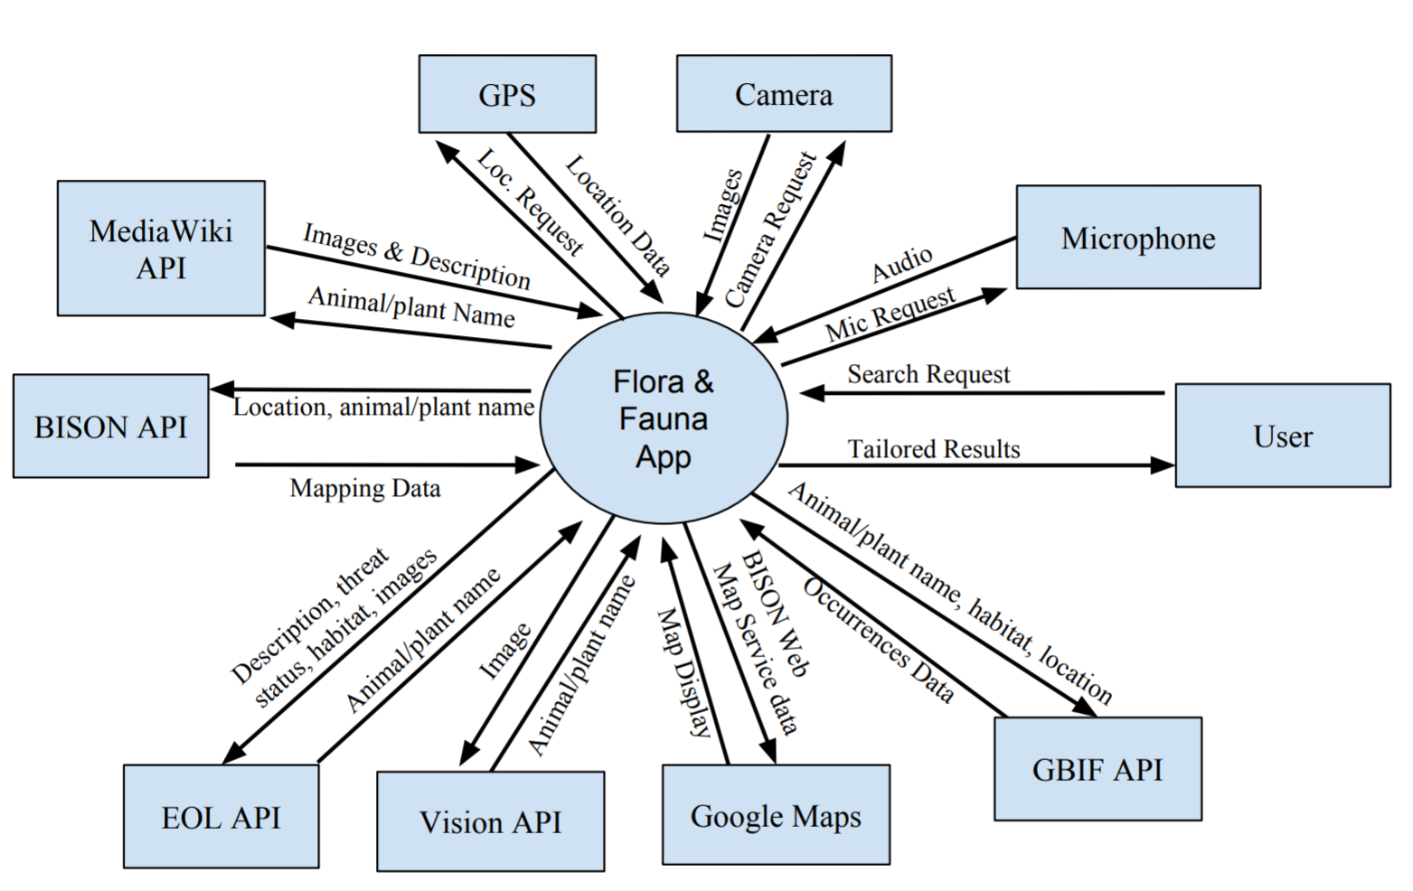

**Data Flow Diagram**

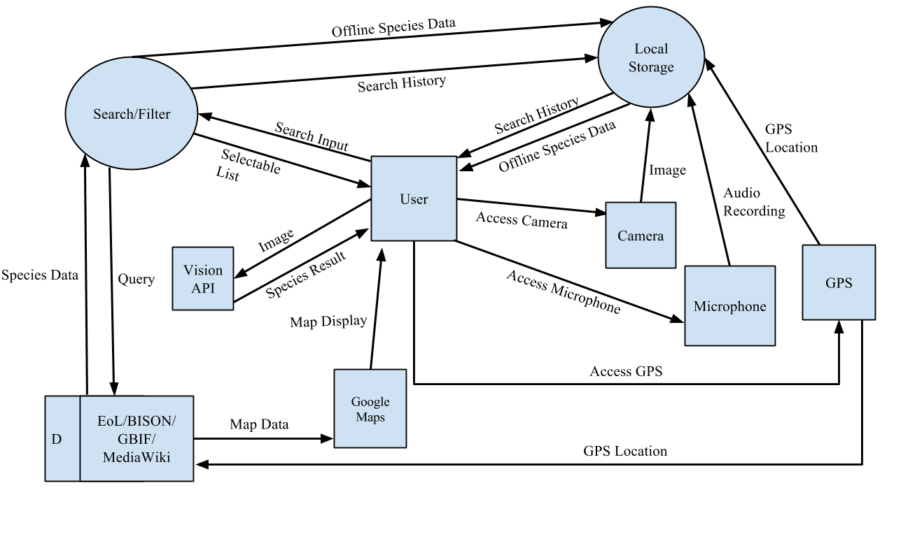

**Use Case Diagrams**

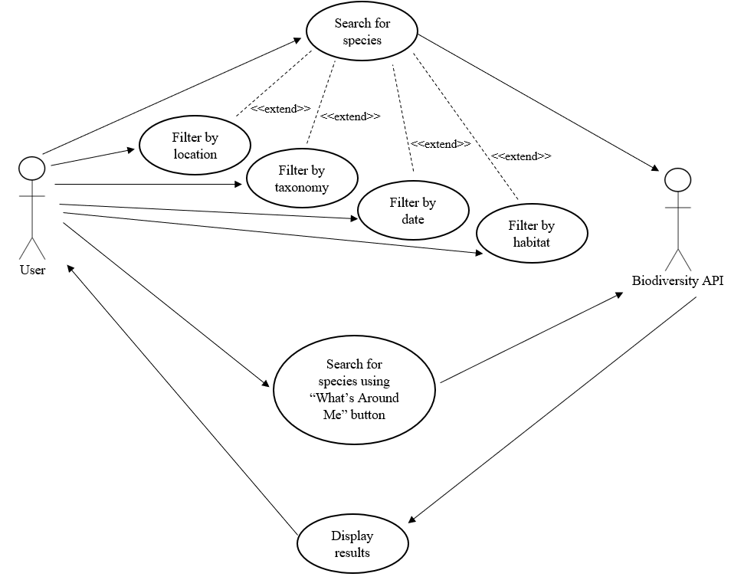

***Diagram 1:*** *Use Case for searching and “What’s Around Me” feature.*

|  |  |
| --- | --- |
| **Filter by location** | |
| Actors | Users of the application, Biodiversity API |
| Description | The user can filter organisms by state and/or county. The user can also filter results using their GPS location. Using GPS, the application will only display results within a set radius of the user. |
| Data | The location information is sent as a query to a database. |
| Stimulus | User selecting a location in the filter results menu. |
| Response | The application will only display results in the location the user provided. |

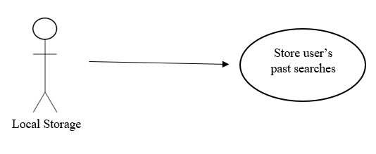

***Diagram 2:*** *Use Case for local storage.*

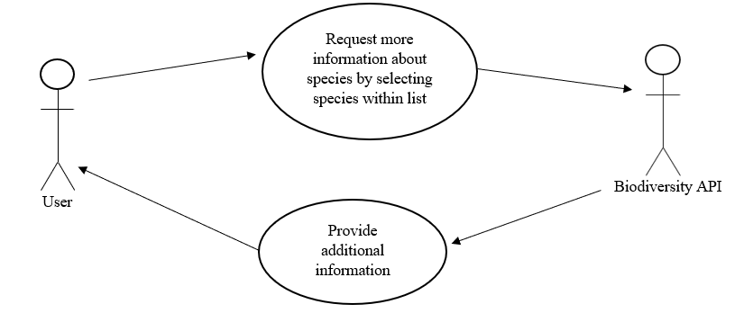

***Diagram 3:*** *Use Case for pulling species description*

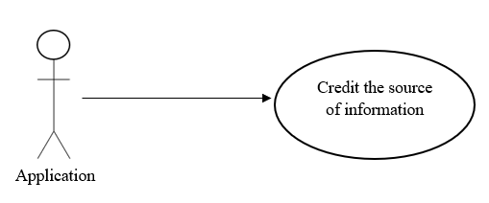

***Diagram 4:*** *Use Case for crediting of sources*

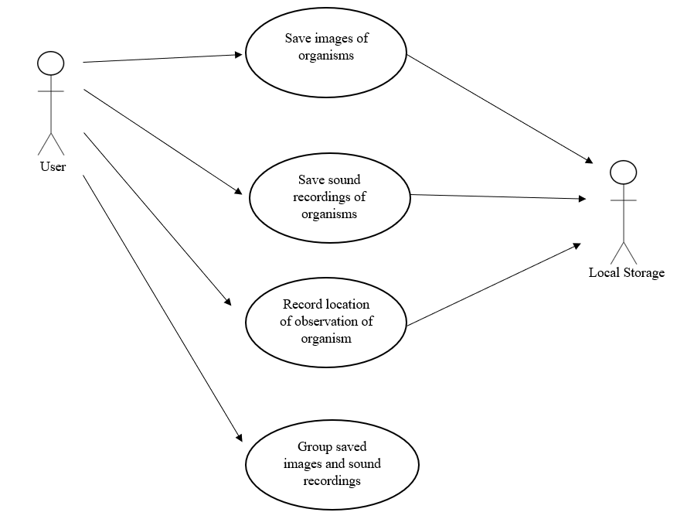

***Diagram 5:*** *Use Case for the local storage of sightings and user pictures*

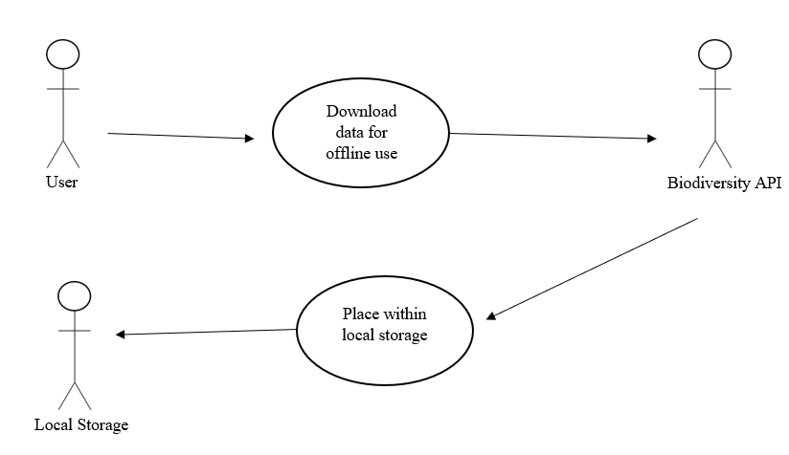

***Diagram 6:*** *Use Case for the downloading of data for offline use*

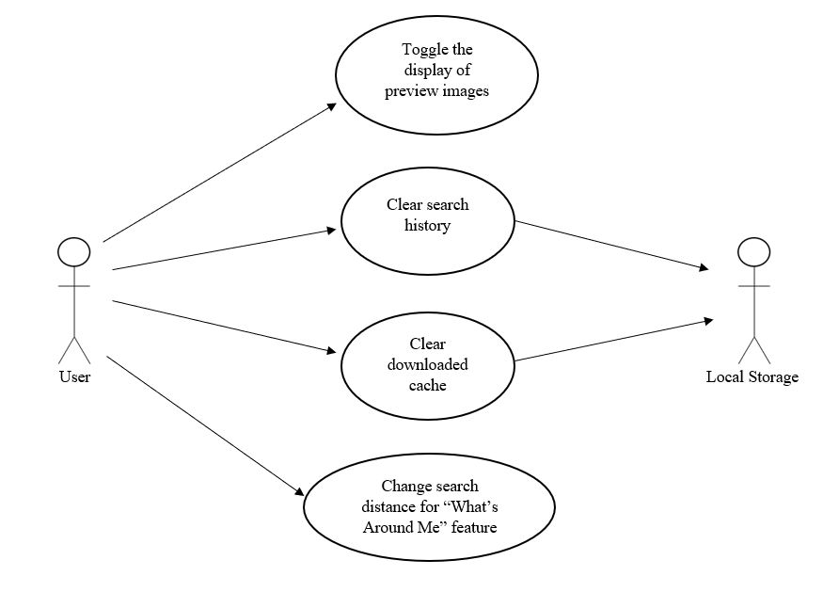

***Diagram 7:*** *Use Case for application settings menu*

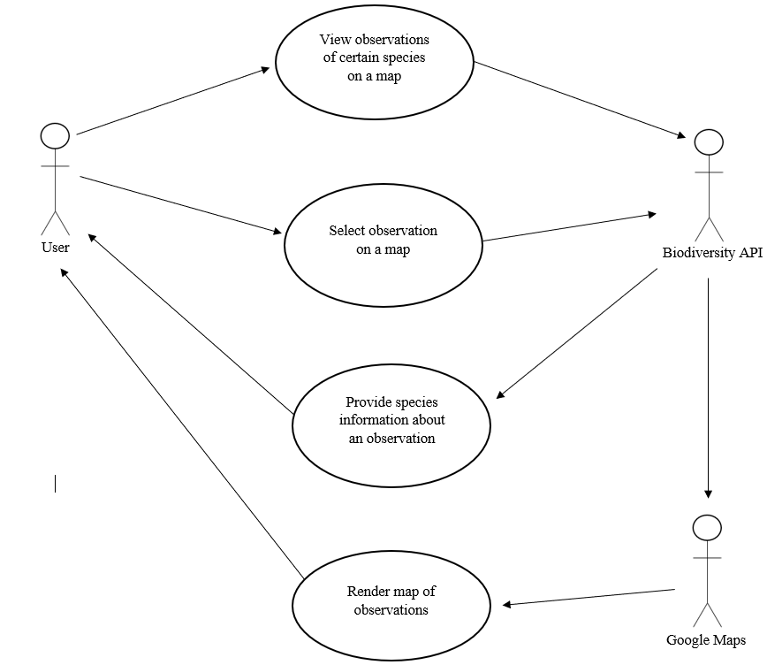

***Diagram 8:*** *Use Case for rendering and viewing map data*

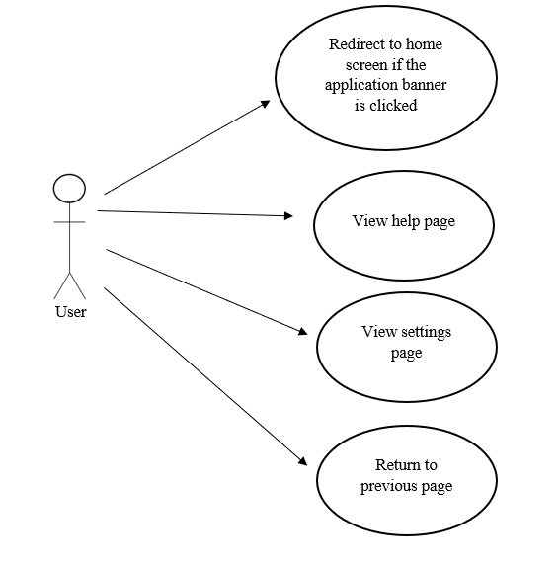

***Diagram 9:*** *Use Case for general application features*

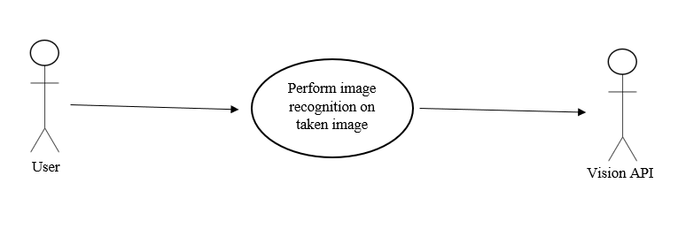

***Diagram 10:*** *Use Case for image recognition subsystem*

**Prototype Information**

**Initial Prototype**

Below is the initial prototype for the Flora application. It includes the home screen of the application that uses buttons to direct the user to the features of the application. The general search would be used if the user wanted to perform a simple search such as searching for spiders in their area. The advanced search would be used if the user wanted to search for organisms using their taxonomy information such as kingdom, phylum, class, order, family, genus, and species.

It also includes a search bar that the user would use to search for species in a given location. The category drop-down bar would represent the kingdom of the organism and the type drop-down bar would represent the family of the organism. The user could select a date to view organisms that are in the given location at the chosen date.

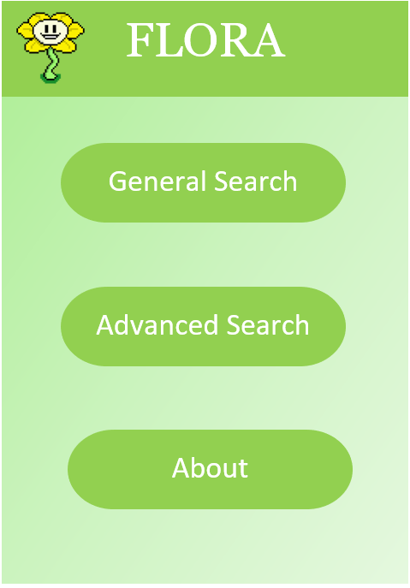

**Second Prototype**

For the second prototype, some additional features were added based on customer feedback. The way searches were performed was changed, and the user interface was modified.

Below is the modified home screen.

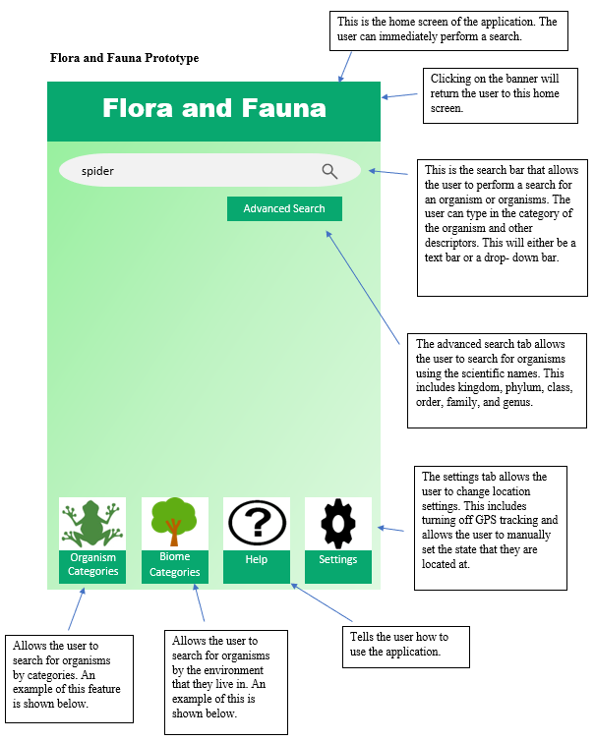

Below is an example of a user’s search.    
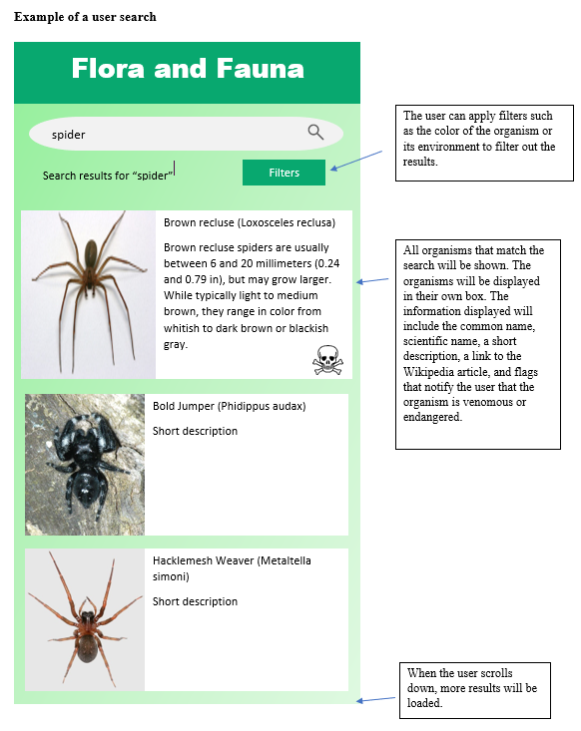

Below is an example of the user using the Organism Categories feature.

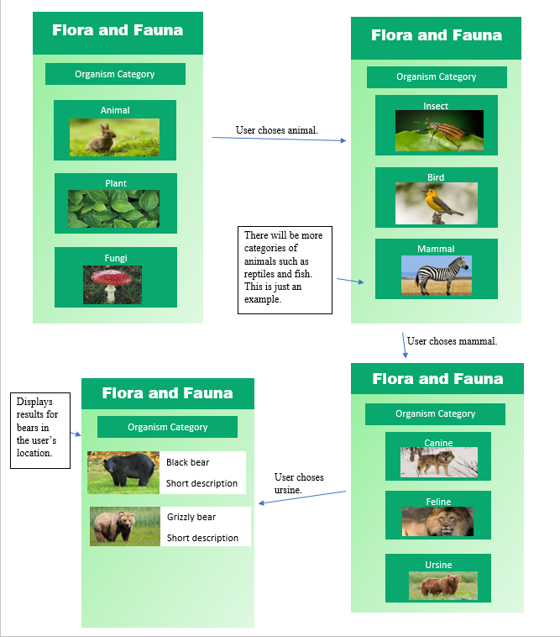   
  
  
  
  
  
  
  
Below is an example of the user using the Biome Categories feature.

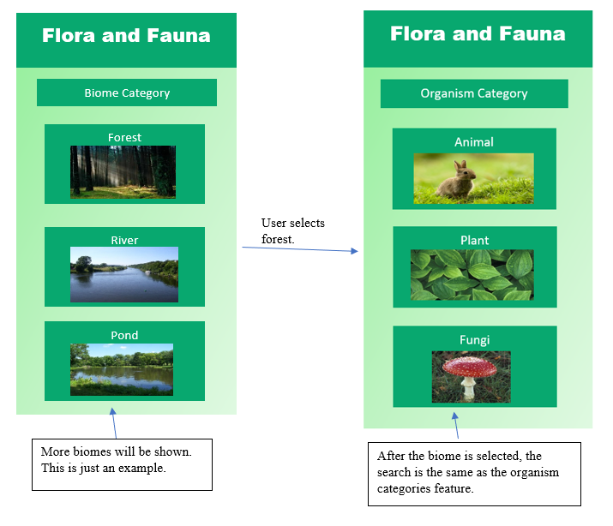

**Prototype Objectives**

1. Determine how the filters/categories would function
2. Figure out format of the home screen with the search box and other options
3. Decide on the appearance of the user interface
4. Receive feedback from clients on the usability of the user interface

**Prototype Feedback**

1. Todd Buffington - We sent Todd the initial prototype, and he gave us the following feedback:

“One thing that hit me right off is to eliminate choices by habitat type. A bottomland-hardwood habitat would have different species than upland-pine. It could also be broken down by aquatic or terrestrial. There may be some way to utilize the GPS function of a smartphone to establish habitat type using existing GIS data.”

This feedback urged us to look into the development of filters. We discovered the GBIF API which will allows us to filter by habitat. The BISON Web Map Service along with Google Maps will utilize the GPS function of the smartphone for creating maps which will show the user species observations. Todd has not sent feedback on the second prototype.

1. Dr. Box Leangsuksun - Dr. Box responded to our initial prototype by urging us to look into existing applications. He spoke with us about adding where a user can upload their own pictures and audio recordings. Additionally, he suggested we look into image recognition, but he warned that it may not be incredibly accurate.

After showing Dr. Box the second prototype, he suggested that we allow for a social aspect within our application. With this feature, users would be able to see the recorded observations uploaded by other users. Currently, we do not plan to do this, considering the additional challenge of login and security aspects. Dr. Box also recommended that the application have a feature where the user can download data from a set location for offline use since most users would be in locations with limited or no cellular service.

**Requirements Affected**

1. FR2
2. FR3
3. FR10
4. FR12
5. FR16
6. FR17
7. FR20
8. FR22
9. FR29
10. FR30
11. FR32
12. FR33
13. NFR1

**System Evolution**

**Fundamental Assumptions**

* The application is an Android mobile application.
* The primary goal of the application is to allow the user to search for information about species and to display the observations of the species in the user’s location.
* The application will use the EOL API, the GBIF API, and the MediaWiki API to display information about species.
* The application will use the BISON API to display the observations of species using its BISON Web Map Service.
* The application will locally store a user’s past searches as well as species data for offline use.
* The application can access the user’s GPS location. The application will prompt the user if they will allow the application to use their location.

**Anticipated Changes**

* If meshing data from multiple databases is difficult or slow, we will only use one database to retrieve species’ information and use the BISON API for the observation data.
* Potentially create an AWS database for our application database if local storage will not meet our needs.
* Allow users to upload an image of an unknown organism to seek identification from other users.
* Add a social aspect which allows users to share their recordings with other users.
* Look into other image recognition APIs if Google’s Vision API is not accurate enough.
* Scale the application to work on Android tablets.

**Client Signatures**

**Dr. Box Leangsuksun**

Dr. Box is currently out of the country and has not yet been able to review and sign the document.

**Todd Buffington**

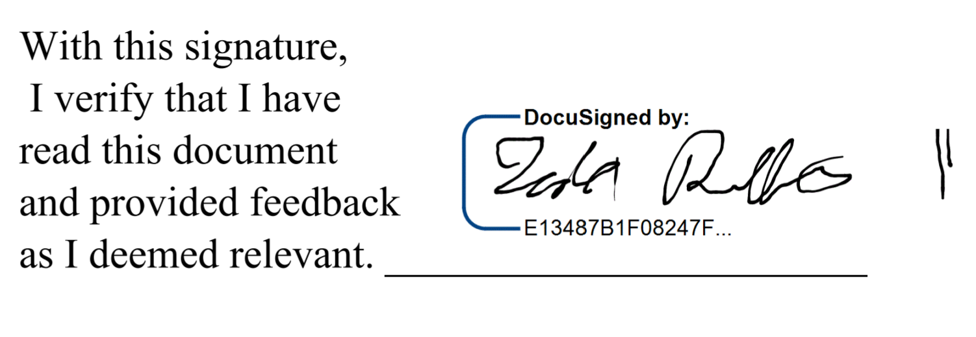

**Emma Boehm**

